**PROJECT DESIGN PHASE-II**

**TECHNOLOGY ARCHITECTURE**

|  |  |
| --- | --- |
| **TEAM LEAD**  **TEAM MEMBER** | **S.MANIRAJ**  **1 ARUNACHALAM**  **2 ASWIN**  **3 ARUN RAJ**  **4 IMMANUEL AUGUSTIN** |
| **PROJECT NAME** | **AI-POWERED NUTRITION ANALYZER FOR FITNESS ENTHUSIASTS** |

**ABSTRACT :**

* The main aim of the project is to building a model which is used for classifying the fruit, vegetables, spinach, fish, meat, Green leafy vegetables etc….. depends on the different characteristics like colour, shape, texture etc. Here the user can capture the images of different fruits, vegetables, spinach, Green leafy vegetables, fish, meat , etc.. and then the image will be sent the trained model. The model analyses the image and detect the nutrition based on the fruits like (Sugar, Fibre, Protein, Calories, etc.).
* Food is essential for human life and has been the concern of many healthcare conventions. Nowadays new dietary assessment and nutrition analysis tools enable more opportunities to help people understand their daily eating habits, exploring nutrition patterns and maintain a healthy diet.
* Nutritional analysis is the process of determining the nutritional content of food. It is a vital part of analytical chemistry that provides information about the chemical composition, processing, quality control and contamination of food.
* This solution helps fitness enthusiasts to do Nutritional analysis of food which provides information about the chemical composition, processing, and quality control of food.
* The chance of occurrence of error is minimal since the model provides more precise reports of the analysis.

**OBJECTIVES:**

* Being healthy should be an integral component of your life. A Healthy intake of food can assist in the prevention of chronic diseases and long-term ailments. What you eat is closely related to your health. Eating a healthy diet can help boost your immune systems, help you maintain a healthy weight and can improve your overall health.
* The importance of diet can't be overstated for a healthy lifestyle. People get the vitamins, minerals and nutrients they need to function and thrive from the foods they eat, so choosing foods that offer the most of those components helps improve quality of life.
* It's just as important to limit foods that are high in fat, sugar, sodium and cholesterol as it is to choose healthy foods.
* Nutrition helps in functioning, maintaining, or improving important bio metabolisms like building muscles, producing energy, thriving body cells, improving body health, replenish malnourishment, and strengthening immunity. If food is the reason, Nutrition is the result.
* Consumers have become more concerned over the quality and compositions of their food purchases, the contained ingredients, and the presence of additives and contaminants. Therefore, knowledge of the chemical and biochemical composition of foods is important to the health, well-being, and safety of the consumers.
* We consume food so that we can obtain proper nutrition. Hence it is very important for us to know the composition of nutrients in our food. Through a nutrition analyzer we can measure the nutrients and with that information we can make a healthy diet by adding nutrients required for our body and excluding which is not good for health.

**TECHNOLOGY ARCHITECTURE:**

-Food Types

-The area of the food types should be Estimated (Area estimation)

Input Image

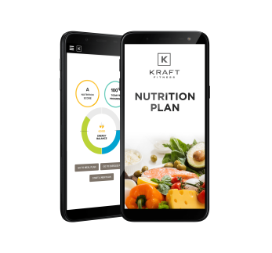 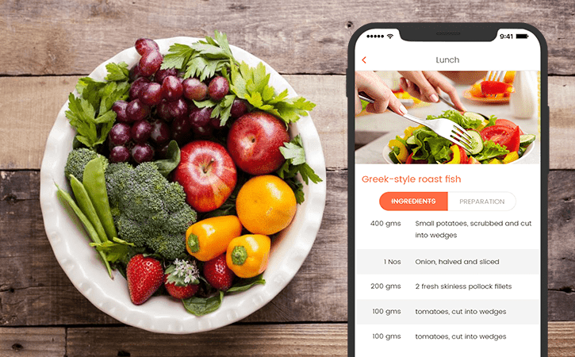

Client

c

Volume and Density Estimation of the Food content

Server



At last the output is determined by the food images with the nutritional content facts table and give a better feedback about the food. It also says the content the food that we consume like apple, carrot, grapes etc...

+

OUTPUT



-Visual Characterization

-Nutrient Information of the food

Research Community

User Confirmation and Adjustment